Procedure to prepare Egg-Fried-Rice

1. Gather the required ingredients

* The list of Ingredients required are:
  + 2 cups of dry long grain white rice
  + ½ of a small yellow onion
  + 1 clove of garlic, 2 eggs
  + 1 tablespoon of salt
  + 1 tablespoon of pepper
  + 4 tablespoon of low sodium soy sauce
  + 1 ½ tablespoon of vegetable oil
  + 1 tablespoon of sesame oil
  + 1 Spring onion for garnishing
  + 4 cups of water

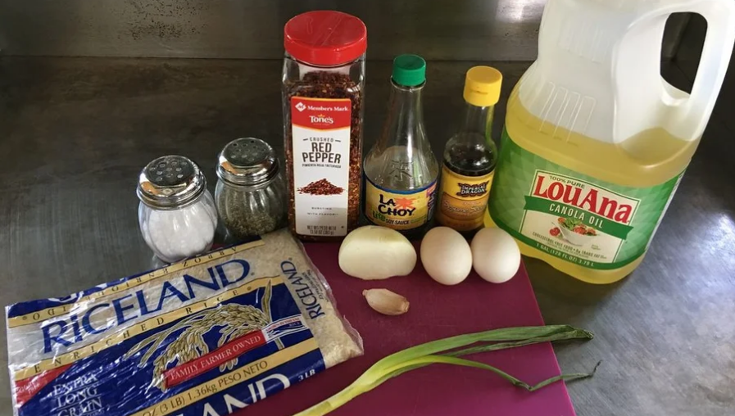

1. Gather the required tools

* The tools required for this recipe are:
  + Deep or large pan
  + Small pan for frying egg
  + Spatula
  + Bowls
  + Medium saucepan with lid
  + Measuring cup
  + Chef or paring Knife
  + Measuring spoons
  + Chopping Board

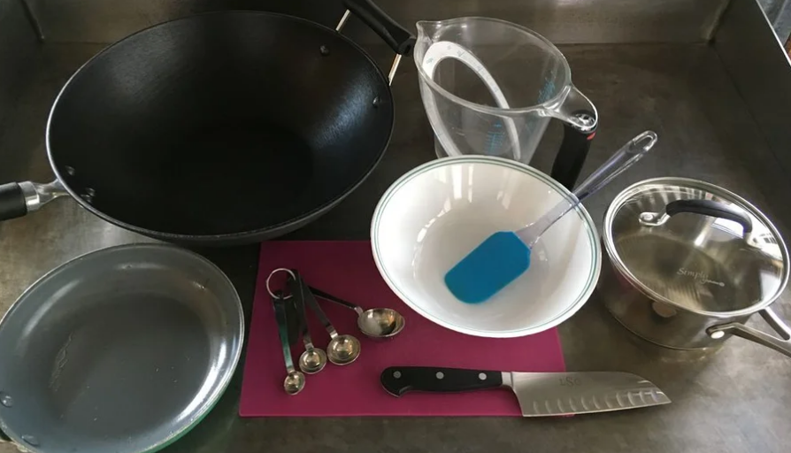

1. Measuring

* Measure 2 cups of rice with 4 cups of water.

1. Bringing to a boil

* Boil the rice

Note: Turn the burner on high flame, until the rice and water in the saucepan is boiling. When the water is boiling turn the flame to simmer and apply lid for 20 to 25 minutes.

1. Dicing

* Dice the onion using the chef or paring knife, while waiting for the rice to be cooked.

1. Mincing

* Mince the garlic into smaller pieces using chef or paring knife.

1. Add oil for frying

* Heat 2 tablespoon of vegetable oil in a large pan set on a medium flame.

1. Preparing veggies

* Add onion and garlic to the heated oil along with salt and pepper, stir frying till it is turns aromatic.

1. Scramble eggs

* Scramble eggs with ½ tablespoon of vegetable oil in a separate pan and set aside once done, while waiting for the onions to turn aromatic.

1. Adding the rice

* Add the cooked rice in large pan along with onions and garlic.

1. Add seasons

* Add the soy sauce, sesame oil, and red pepper flakes along with the rice.

1. Last ingredient to be added

* Add the scrambled egg at last after adding all other ingredient.

1. Stir Fry

* Constantly stir fry the rice with spatula, for 3 to 4 minutes.

1. Finally

* ENJOY! The hot and tasty fried rice, transferred in a serving plate with spring onion topping.